BUDO JUNIOR SCHOOL
REMEDIAL WORK FOR TERM 1 2020 - SET TWO
RELIGIOUS EDUCATION FOR PRIMARY ONE

Name: _________________________________________________________________________
Stream: ________________ Date: _________________________________________

1. What is your religious name?
__________________________________________________________

2. Write four Christian names that you know.
(i)______________________ (ii)________________________

(iii)_____________________ (iv)_______________________

3. a) _______________________ means rock.

b) _______________________ means worker.

c) ______________________ means savior.

4. Write four gifts God gave you.
(i)______________________ (ii)________________________

(iii)_____________________ (iv)_______________________
5. Draw these parts of your body.
tongue | head | ears | mouth

6. Match people at school to their roles.
cook heads the school.
teacher cooks food.
bursar teaches pupils.
headteacher collects school fees.
7. ____________________treats sick children.

8. Name these people found in the community.
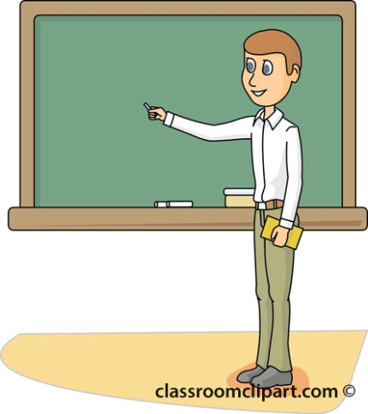 | 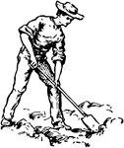 | 
( driver , cook , farmer , teacher )
9. Give four things found in a church.
(i) __________________________________________________________
(ii) ________________________________________________________
(iii) ________________________________________________________
(iv) ________________________________________________________

10. Where do you go when you are sick?
__________________________________________________________

11. We should ___________ to God when we are sick. ( play , pray)

12. Draw these people found at school.
cook | cleaner | teacher | children

13. Fill in the missing letter.
d___nkey li__n ele__ha___t

14. Write two birds God created.
(i)____________________ (ii) _______________________

15 I use a _________________to brush my teeth.
16. Name these things we use to clean the body.
 | 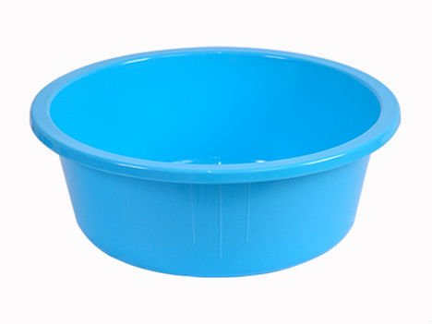 | 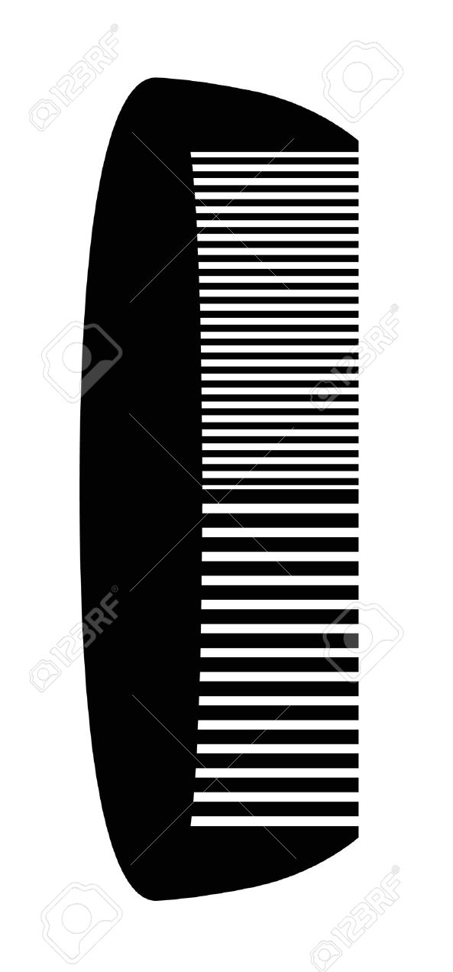 | 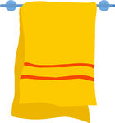

17. Draw yourself washing clothes.

18. Choose the correct word to complete the story.

Reverend Bible Sunday church

Every ____________________ I go to _________________to pray.
I go with my ________________ and the _________________
leads us in prayers.

